CHANGE TO HOMESEARCH LOGGING IN PROCESS

Following an upgrade to the Homesearch bidding system on 13th January 2025, a new level of security has been added to your login process. You will now need to have a password to log in as well as your bidding number and memorable date.

If you have not set up your password you will need to do this by following this process:

Go to the Homesearch website: [www.Southwarkhomesearch.org.uk](http://www.Southwarkhomesearch.org.uk)

Click Login in the top right hand corner

Enter your bidding number starting with 3 in the ‘Your login reference’ field

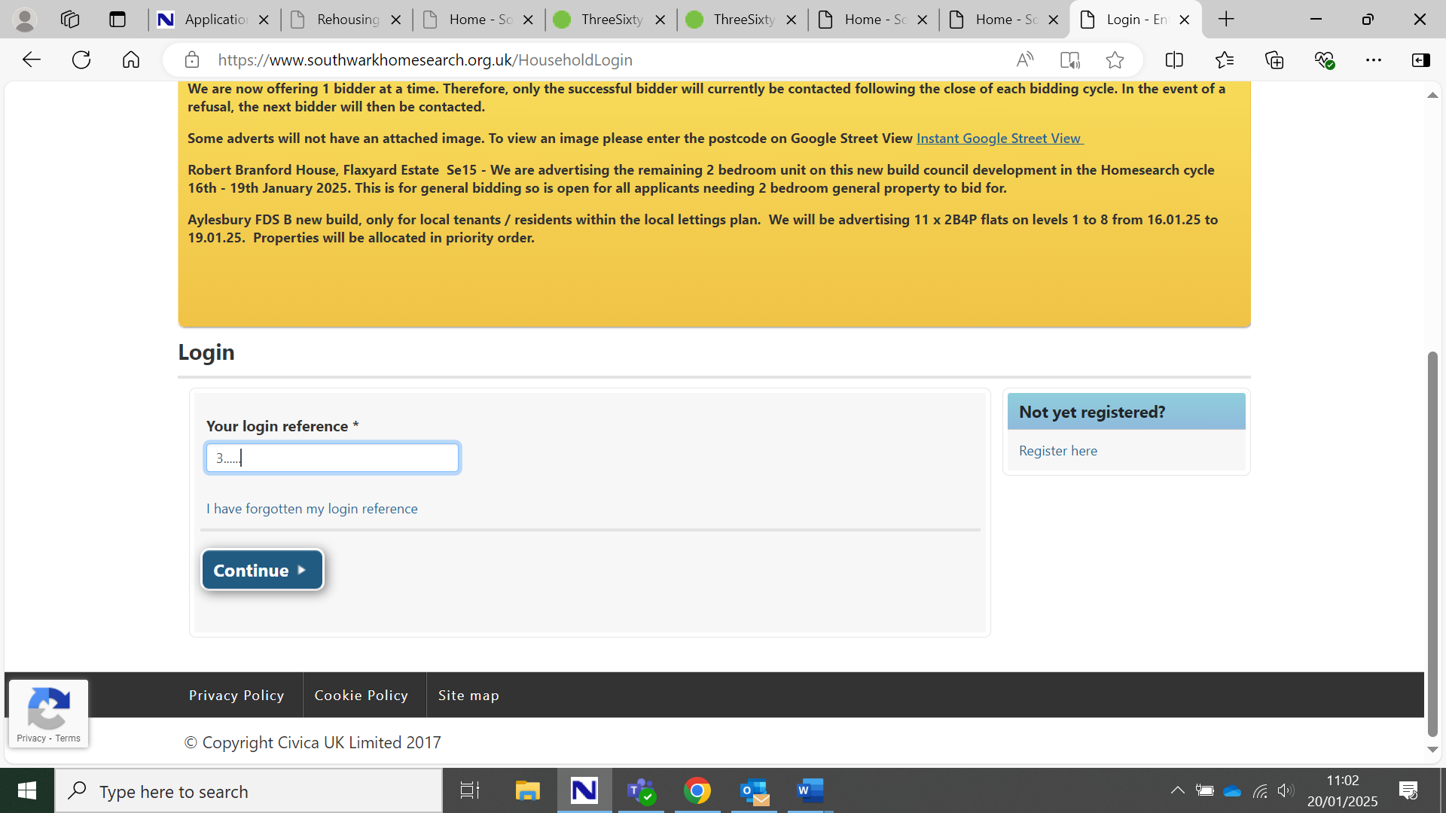

Click Continue

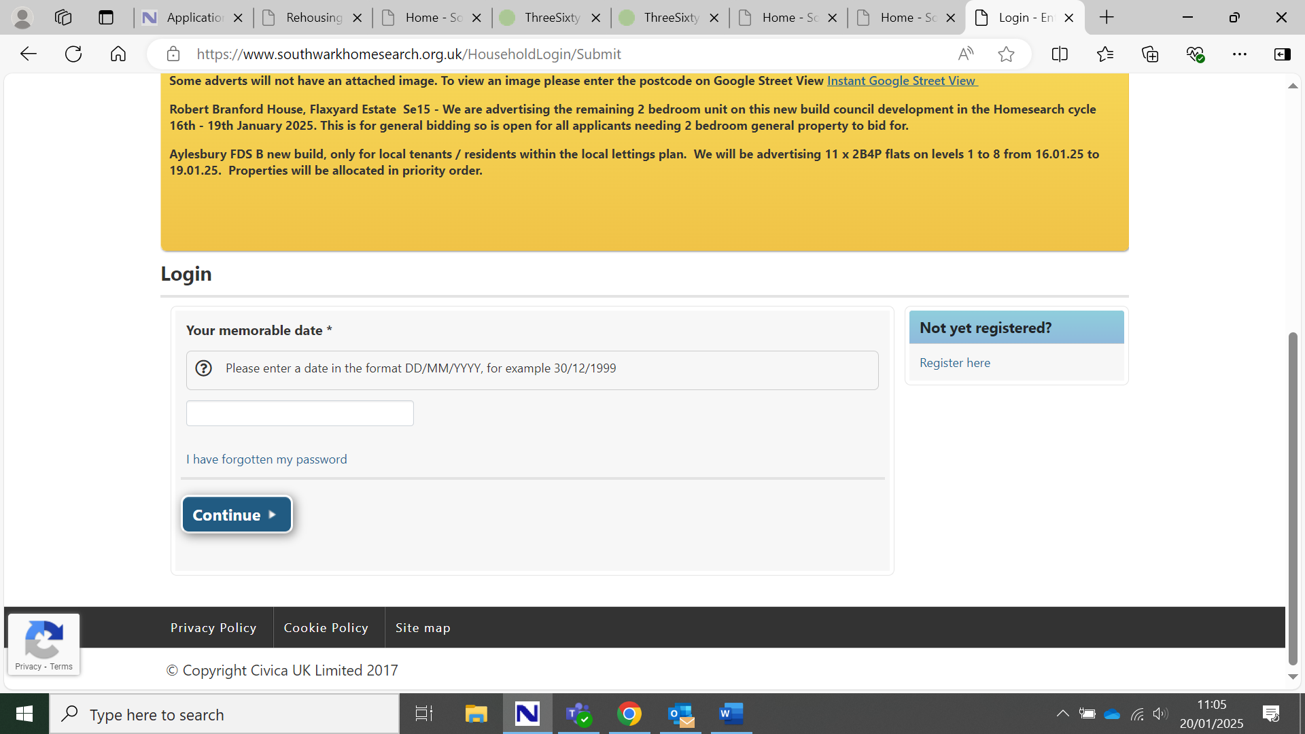

Do not enter your memorable date at this stage

Click ‘ I have forgotten my password’

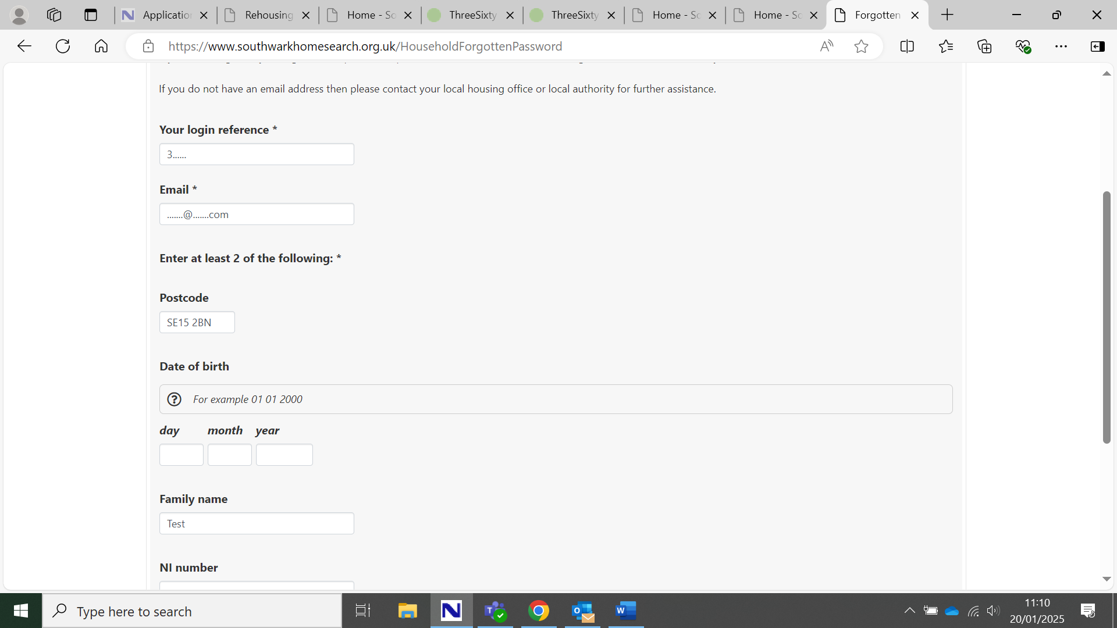

Complete the form that is displayed. You must include your bidding reference number and the email address that is connected to your Homesearch account. You must also complete at least 2 of the other fields. You do not need to complete all of them. Click ‘Reset’ at the bottom of the page.

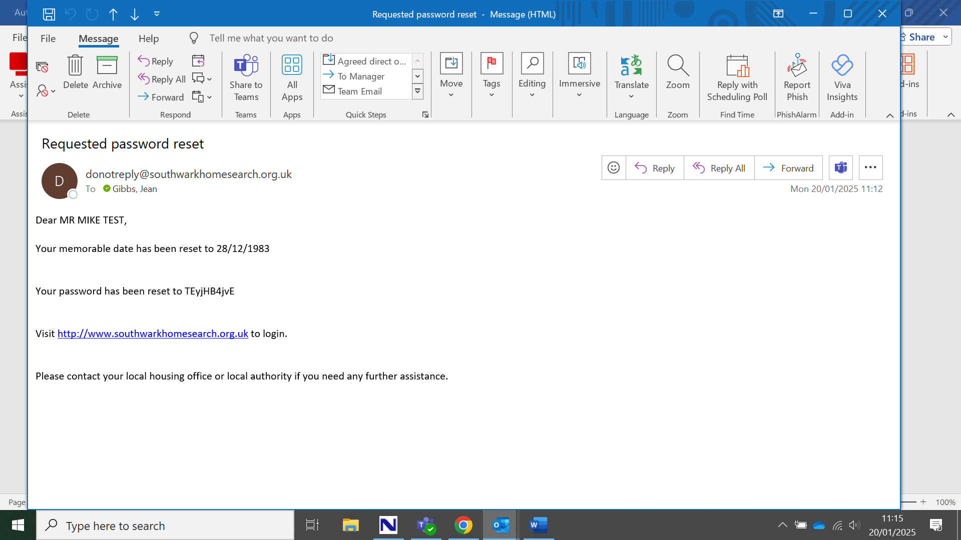

You will receive an email as above. This will give you **a new memorable date** and password to log in with.

Go back to the website , click login and put your bidding number in**. Use the new details from the email for the memorable date and password fields**.

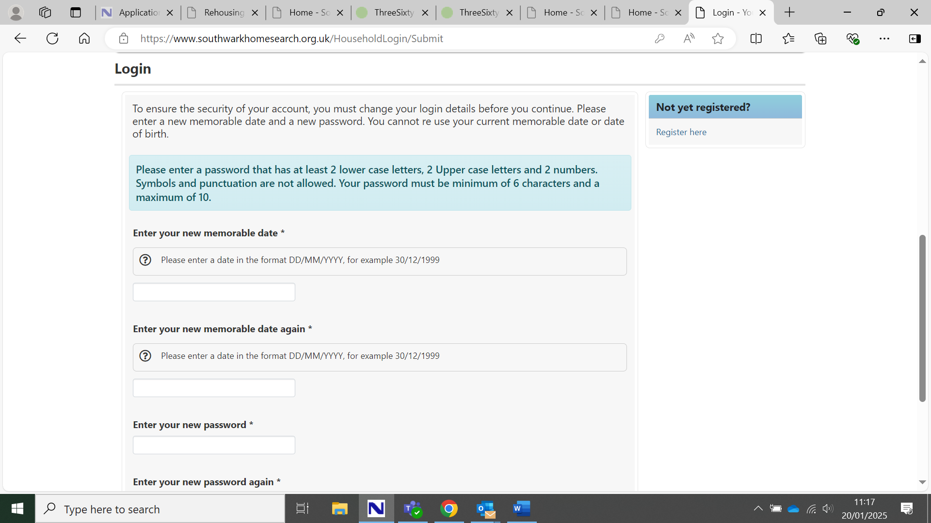

It will now ask you to create a new memorable date and password. We advise you set the memorable date to your date of birth as you used to do . Make sure you enter it in both fields exactly the same. You **must use dd/mm/yyyy**. So if your date of birth is 25th December 1998, you must enter 25/12/1998

Create a new password: **you must make sure it meets these rules**:

It must be **at least 6 characters but not more than 10 characters**. It must have at least **2 upper case letters** and at least **2 lower case letters** and at least **2 numbers**. You must not use any spaces or any symbols. An example of an acceptable password is: SUnset2025

Click ‘update details’ at the bottom of the page.

You will then be taken into your account. You will need to remember the memorable date and password you set so you can use these whenever you log onto your Homesearch account